A000-Asia-China-Zhou-Ding-Bronze-c 1100 BCE

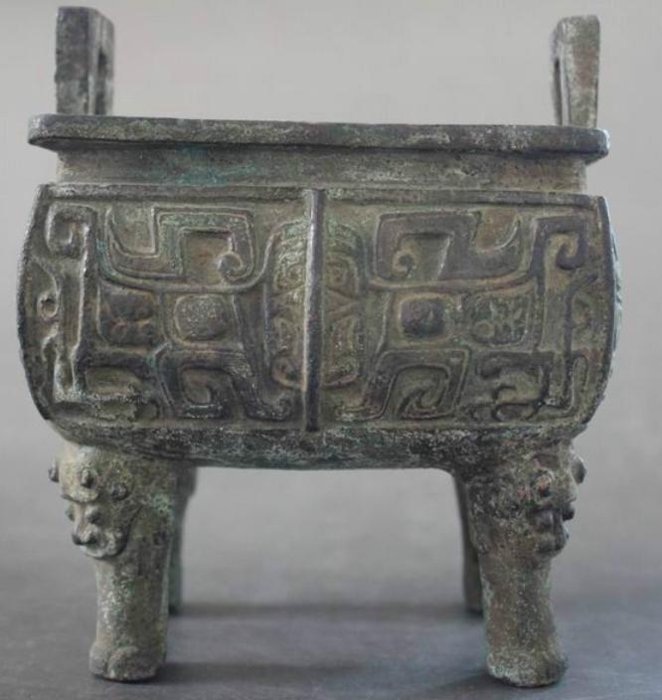

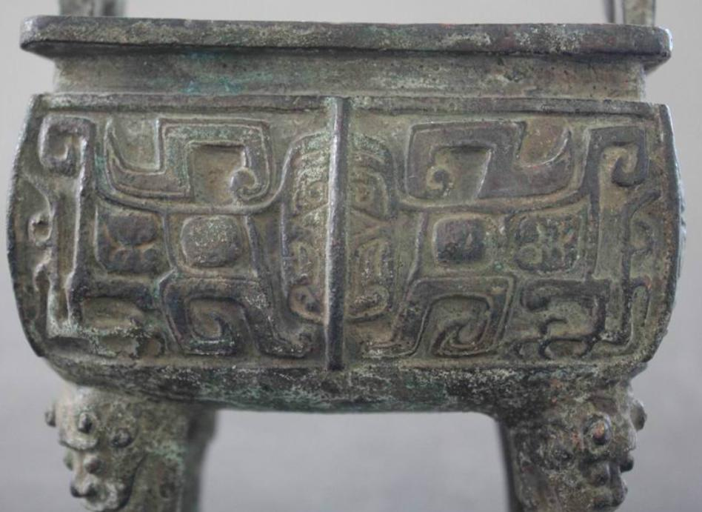 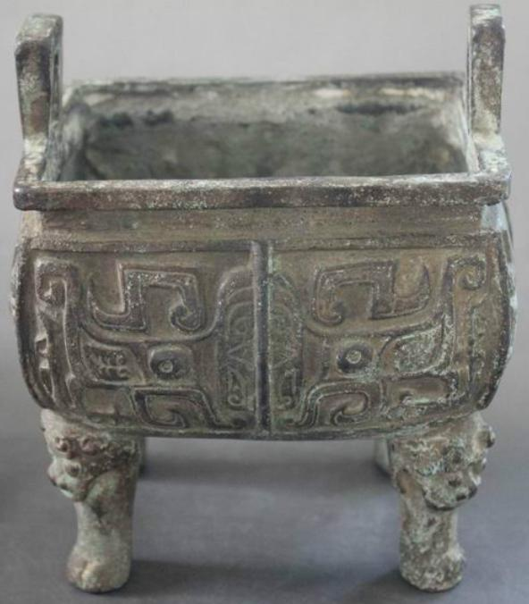 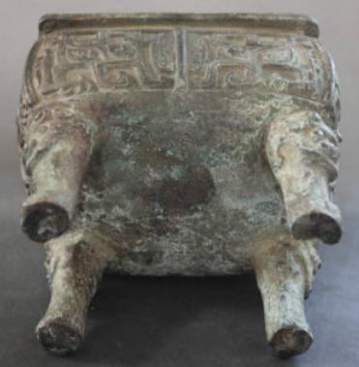

China-Zhou-Ding-Bronze-c 1100 BCE

Case No.: 5

**Accession No.**

**Formal Label:** China-Zhou-Ding-Bronze-c 1100 BCE

**Display Description: after Wikipedia**

Sacrificial vessel (祭器), originally a cauldron for cooking and storing meat (食器). The Shang prototype has a round bowl, wider than it is tall, set on three legs (足); there are two short handles on each side (耳). Later examples became larger and larger and were considered a measure of power. It is considered the single most important class of Chinese bronzeware in terms of its cultural importance. There is a variation called a fāngdǐng (方鼎) which has a square bowl and four legs at each corner. There exist rare forms with lids. 西清古鑒 contains over two hundred examples, and this is the most highly regarded of all Chinese bronzes.

**LC Classification:**

**Date or Time Horizon: 1100 BCE**

**Geographical Area:**

**Map:**

**GPS coordinates:**

**Cultural Affiliation:**

**Media:**

**Dimensions:**

Length: 5 inch

Width: 4 inch

Height: 6 inch

**Weight:** 3 kg

**Condition:**

**Provenance:**

**Discussion:**

**References:**